Draft Jamaican Standard

Guide

for

Compliance management systems – Requirements with guidance for use

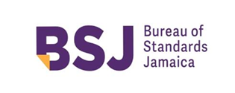

BUREAU OF STANDARDS JAMAICA

NON-OBJECTION PERIOD: 12 JANUARY 2022 –
12 FEBRUARY 2022

IMPORTANT NOTICE

Jamaican standards are subjected to periodic review. The next amendment will be sent without charge if you cut along the dotted line and return the self-addressed label. If we do not receive this label we have no record that you wish to be kept up-to-date. Our address:

Bureau of Standards Jamaica
6 Winchester Road
P.O. Box 113
Kingston 10
Jamaica W.I.

---------------------------(cut along the line)------------------------------------------------------------------------------------------

DJS ISO 37301: 2022

NAME OR DESIGNATION…………………………………….………………………………

ADDRESS……………………………………………………….………….……………………

……………………………………….…………………………………………………………….

……………………………………………………………………………………………………..

JBS CERTIFICATION MARK PROGRAMME

The general policies of the JBS Certification Mark Programme are as follows:

- The JBS provides certification services for manufacturers participating in the programme and licensed to use the gazetted JBS Certification Marks to indicate conformity with Jamaican Standards.

- Where feasible, programmes will be developed to meet special requirements of the submitter. Where applicable, certification may form the basis for acceptance by inspection authorities responsible for enforcement of regulations.

- In performing its functions in accordance with its policies, JBS will not assume or undertake any responsibility of the manufacturer or any other party.

Participants in the programme should note that in the event of failure to resolve an issue arising from interpretation of requirements, there is a formal appeal procedure.

Further information concerning the details of the JBS Certification Mark Programme may be obtained from the Bureau of Standards, 6 Winchester Road, Kingston 10.

CERTIFICATION MARKS

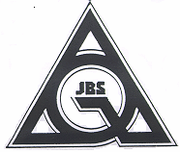

Product Certification Marks Plant Certification Mark

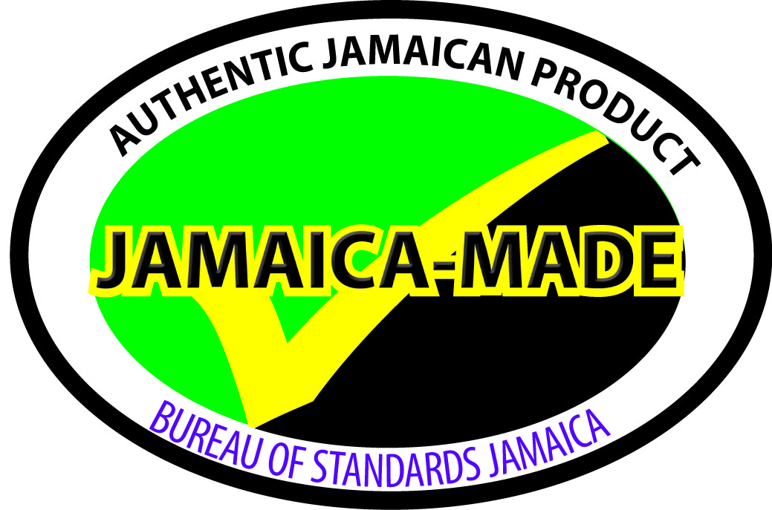

Certification of Agricultural Produce Jamaica-Made Mark
(CAP) Mark

Draft Jamaican Standard

Guide

for

Compliance management systems – Requirements with guidance for use

Bureau of Standards Jamaica
6 Winchester Road
P.O. Box 113
Kingston 10
Jamaica W. I.
Tel: (876) 926 -3140-5, (876) 618 – 1534 or (876) 632-4275
Fax: (876) 929 -4736
E-mail: info@bsj.org.jm
Website: www.bsj.org.jm

Month 202x

© 202x Bureau of Standards Jamaica
All rights reserved. Unless otherwise specified, no part of a Bureau of Standards publication may be reproduced or utilized in any form or by any means, electronic or mechanical, including, photocopying microfilm or scanning, without permission in writing.

ISBN XXXXXXXXXX

Declared by the Bureau of Standards to be a standard guide pursuant to section 7 of the Standards Act 1969.

First published Month 202x

This standard was circulated in draft form for thirty (30) days non-objection under the reference DJS ISO 37301: 2022
Jamaican Standards establish requirements in relation to commodities, processes and practices, but do not purport to include all the necessary provisions of a contract.

The attention of those using this specification is called to the necessity of complying with any relevant legislation.

Amendments

No. | Date of Issue | Remarks | Entered by and date

Contents

Page

National foreword v
Acknowledgement v

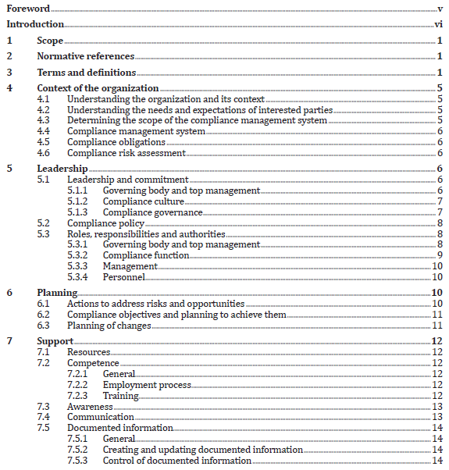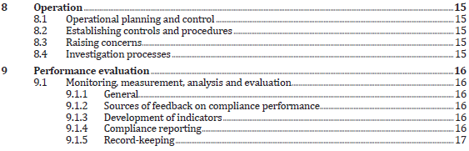

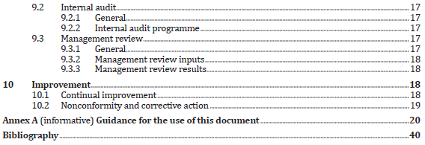

National foreword

This standard is an adoption and is identical to ISO 37301: 2021 Compliance management systems — Requirements with Guidance for use published by the International Organization for Standardization.

Scope of the standard
This document specifies requirements and provides guidelines for establishing, developing, implementing, evaluating, maintaining and improving an effective compliance management system within an organization.

This document is applicable to all types of organizations regardless of the type, size and nature of the activity, as well as whether the organization is from the public, private or non-profit sector.

All requirements specified in this document that refer to a governing body apply to top management in cases where an organization does not have a governing body as a separate function.

The guidelines of this document are generic and intended to be applicable to all organizations, regardless of type, size, nature of activity, and whether in the public, private or not-for profit sectors.

Where the words 'International Standard' appear, referring to this standard, they should be read as 'Jamaican Standard'.

Where reference is made to informative and normative annexes the following definitions should be noted:

- Informative Annex – gives additional information intended to assist in the understanding or use of the document. They do not contain requirements.

- Normative Annex – gives provisions additional to those in the body of a document. They contain requirements.

Users should note that all standards undergo revision from time to time and that any reference made herein to any standard implies its latest edition, unless otherwise stated.

This standard is voluntary.

Acknowledgment
Acknowledgement is made to the International Organization for Standardization (ISO) for permission to adopt ISO 37301: 2021

